

The Mentor Files - File No. # 101 Why Procrastination is stealing your money every single day! Let us show you how to join the World’s TOP 1% Income Earners! Mr. James S. Davis Jr. President / CEO / Founder / Syndicated News Columnist This author’s syndicated News & Internet Column “The Mentor Files” has been read by more than 500,000,000 since 1996 and is considered to be “The Nations Mentor & Consumers Advocate” You can Enjoy and Benefit from your own personal MENTORS POINT OF VIEW! Email: info@SixFigureClub.com Web: www.SixFigureClub.com

Everyone’s Daily Cost for Procrastination based Annual R.O.I. Total Yields!

This is based on your earning everyday - 3 6 5 - days per year the following D A I L Y - R E T U R N S !!!

If you can afford to lose this daily income… Perhaps this is not for you.
Note: This is how Millionaires become Multi-Millionaires & 99% of the public won’t!!!!
You may enter with as little as $25k-$100k-$250k-$500k-$750k-$1m-$3m-$5m-$10m-$25m-$50m-Even $100m and more has been Monetized into Serious Monthly Passive Income…..PROFITS!
Our “Participants” May Receive The Following Daily Earnings (PROFITS) & Are Paid Quarterly/Annually!
The following examples are based on a $100,000. or $1,000,000. Deposit. The annual earnings were divided by 365 days per year. These were
the projected gross earnings generated PER …DAY…IN …PROFITS … Six Figure Club “Private C L U B Members” may earn a projected minimum of up to 6.25% +/- Q U A R T E R L Y !!! Are you prepared to “Join The Inner Circle of WEALTH?”

So… you can become our beneficiary, or you will LOSE the following remarkable Daily Earnings!
Choose Wisely!!! You need to understand these numbers!
↓ BOTTOM – LINE ↓ Examples: When $100k or $1m deposit in our Legal Bank TRUST Holding Account may earn each depositor within the Six Figure Club -- Profit Center Programs (PCM) Private C L U B Member = Daily (ROR) Rate of Return or Earned Interest.
Examples: below are based on a *projected up to 25%, 35%, to 50% or greater earnings annually. Under the Your Earnings Link, Please see the (PSC) Profit Sharing Compensation Graphs & Charts as PROOF of the passive & earned income our members & company representatives are entitled to receive as our next…. B E N E F I C A R I E S !!!
CAN YOU AFFORD TO P R O C R A S T I N A T E
A N O T H E R - D A Y ???
FOR -- EACH -- DAY -- YOU -- WHO -- P R O C R A S T I N A T E & delay our simple presentation & financial executive summary overview from taking place… If you were approved as one of our Private C L U B Members….

You will have a PASSIVE INCOME! * M I N I M U M - L O S T – P E R D A Y !!!
(Min.) $100,000. @ 25% Annual Earnings ROI = $25,000. / 365 days = $68.49 * PROFITS P E R - D A Y I N L O S S E S !
(Min.) $100,000. @ 35% Annual Earnings ROI = $35,000. / 365 days = $95.89 * PROFITS P E R - D A Y I N L O S S E S !
(Min.) $100,000. @ 50% Annual Earnings ROI = $50,000. / 365 days = $136.98 * PROFITS P E R - D A Y I N L O S S E S !
Note: Many of our (HYRPIPS) High Yield Return Passive Income Programs/Systems have generated far greater R.O.I.’s for our Private Members!
You only need to show your ability to provide the (POF) proof of funds with a financial statement, photocopy of your passport or driver’s license, banking details where to forward your earnings when distributions were due (QUARTERLY or ANNUALLY) wired to your financial institution (BANK ACCOUNT.)
See this link to how THE 10 X F A C T O R Can Pay You, Your Business, Your Organizations
↓ $1-M = ($1,000,000.) Deposit / Investment = Daily (ROI) Returns on Investment or Earned Interest/Income. ↓
$1-M @ 25% Ann. Earnings ROI = $250,000. / 365 days = $684.93 *PROFITS P E R - D A Y I N L O S S E S !
$1-M @ 35% Ann. Earnings ROI = $350,000. / 365 days = $958.90 *PROFITS P E R - D A Y I N L O S S E S !
$1-M @ 50% Ann. Earnings ROI = $500,000. / 365 days = $1,369.86 *PROFITS P E R - D A Y I N L O S S E S !
$10+-M @ 100% Ann. Earnings ROI = $10,000,000. / 365 days = $27,397.26 *PROFITS P E R - D A Y I N L O S S E S !
$25+-M @ 300% Ann. Earnings ROI = $75,000,000. / 365 days = $205,479.45 *PROFITS P E R - D A Y I N L O S S E S !
$100+-M @ 500% Ann. Earnings ROI = $500,000,000. / 365 days = $1,369,863.01 *PROFITS P E R - D A Y I N L O S S E S !
*Please Note: All of the above portfolios have been accessible for our Six Figure Club “Private C L U B Members.” Contracts generally are for a 1 year & 1 day holding Period and earnings are monthly for 12 months unless otherwise stated. All financial quotes are based on “Best Efforts” & or are from past “Historical Results” & are never guaranteed. So… It is a clear choice …NOW… You need to contact me personally to…. turn all these RED Numbers into GREEN INCOME!!! Open & Submit → Contact Us

ÉÉÉ TRUE Bottom Line! ÊÊÊ
In The Six Figure Club WORLD…PROCRASTINATION…
HAS A D A I L Y - VERY EXPENSIVE PRICE TAG
Which Will COST YOU - 100% LOST OF THESE DAILY PROFITS!
The following published world wide articles are for your review and proof of our over four decades of successes!
←MONEY MENTORS: EDUCATION IS KEY
QUALIFYING MASTER Customer & Affiliate Vehicles

*All earnings are based on best efforts & are not guaranteed & do not reflect our firms JVP compensation. THE SIX FIGURE CLUB DELIVERS THE ONLY IMPORTANT THINGS THAT OUR MEMBERS CARE ABOUT… SUBSTANTIAL MONTHLY INCOME CHECKS & REMARKABLE R.O.I. PROFITS!
We don’t lend you money … We simply create it for you & those important to you! THIS IS OUR BOTTOM LINE! “Time is always of the Essence” I look forward to your call & written response and thoughts.
Next…. Contact Us Let the $ix Figure Club Monetize your life! Like you, I do not have time for games and our private transactions are funded very quickly based on the ROI’s we deliver so … “Time is of the Essence!”

*** Remember we don’t increase your debts… We eliminate them … With Newly Created Wealth!***
… “Private Members” in the first year may earn very significant PROFITS… Many become “Six Figure Income” Level Beneficiaries. YES, in these types of portfolios they may receive in excess of $100,000. Up to Seven Figures in M O N T H L Y - P R O F I T S ! Qualified applicants may receive a projected minimum up to 10X even up to 100X +/- R.O.I. over what they are currently able to receive/earn in PROFITS! - Which PATH will you take?

RE: Are you interested in becoming OUR NEXT.... BENEFICIARY?

Who needs the Money? You should pass this to those whom you would like to share the Wealth... The 99% of you who don’t OPEN THIS EMAIL … WILL LOSE VERY SERIOUS MONTHLY PASSIVE INCOME FROM USING O. P. M. !!!

The enclosed attachments explain everything you need to understand & what you need
to do in order to become a private member of the World’s TOP 1% Income Earners!

Even if you don’t think you can meet the minimum entry level to participant…
Don’t be concerned because we use leverage & (O.P.M.) Other People’s Money.
At the very least… in most cases we can fund and/or increase your initial entry level of deposit for this private offer… so you can join the… “Inner Circle of WEALTH!”

This is a single one-time offer & will not be resent to you…. So… if you are SERIOUS…

Contact Us

This program has FORTY-FIVE-YEARS OF SUCCESSES TO BACK IT UP!

Plus…. Our firm is expanding and adding 1,000’s of Worldwide (SA) “Super Affiliates & (IBO) Independent Business Organizations with our unique & exciting one of a kind… Global & Social Financial Networks which includes our consortium of syndicated White Label Self-Employed Entrepreneur Business Owners!

Labor-free passive income through our
Pathways to Wealth!
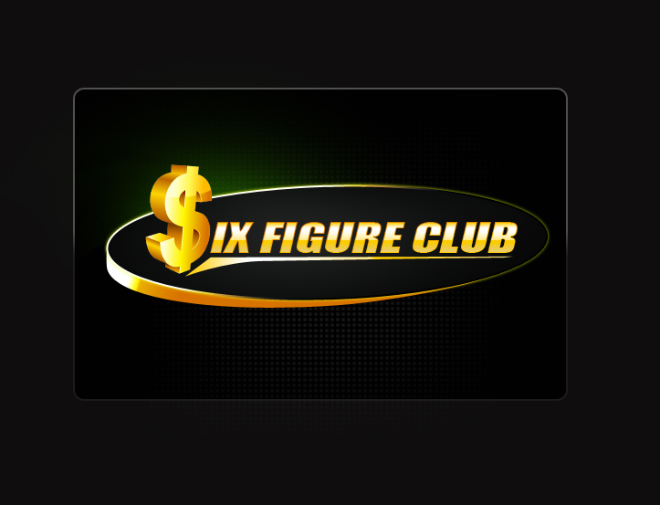
www.SixFigureClub.com
Email: Info@SixFigureClub.com
www.MentorServicesUnlimited.com
Office: 1.(301) 248.1000 Cell: 1.(843) 997-1800
Conf. Call: 1.857.216.6120 Then Enter Code: 84458

Please Note: All correspondence needs to be sent to our H.O. Email: https://sixfigureclub.com/contact-us-2/

ÇTHE REAL BOTTOM LINE! ….Join … The Inner Circle of Wealth!È
AGAIN WELCOME, YOU ARE ON YOUR WAY TO BECOMING OUR NEWEST SIX FIGURE CLUB PRIVATE MEMBER!
We do the work… Not You. We supply the income producing vehicles… You Can’t. We secure the actual portfolios used by the ultra-wealthy… By Invitation Only. We pay YOU serious income from earnings by leveraging (O.P.M.) Other People’s Money… We are inviting you to join our Six & Seven Figure Club……ONCE!

“Which Path Will You Take?”
↓
*** For a NO-Cost & NO Obligation free financial review please complete our Total Needs Analysis form,
visit the website: and fill out the form to review your net worth and financial position.
When you can “QUALIFY,” you will receive full access to our world-wide Passive Income Programs! This consultation normally costs and has a value of $1,650.00!

Simply Contact-Us
“Remember it may cost you Nothing to investigate, but… it could cost you Everything if you don’t!”

Which pathway will you choose? Thank You for the opportunity to become your “New Financial Pathway to Unlimited Wealth!”
YOUR EFFORTS FOR OBTAINING WEALTH WILL BE REWARDED SOONER, WHEN YOU REDUCE, EVEN ELIMINATE RISK, WORRY & LABOR ON YOUR JOURNEY… WE BELIEVE YOUR PATHWAY TO “ARRIVAL” IS A SHORT DISTANCE AWAY!

The Nations Mentor & Public Advocate For Consumers
It’s a simple choice… Choose Wisely!!!
Respectfully, James S. Davis, Jr.
James S. Davis, Jr. - Master Financial Monetizer
Founder/CEO/Chairman/Mentor - 12+ Bus. Enterprises.
Company Website: $ix Figure Club

Next…. Contact Us Let the $ix Figure Club Monetize your life!
The Nations Mentor & Public Advocate For Consumers
If you have not joined as of today simply open ↓↓↓ this link, you too can become one of the TOP 5%ER’S WEALTHEST EARNERS!
This Is The TRUE Bottom Line!
There’s no time to spare! Contact Us today to start earning amazing labor-free income through our
Pathways to Wealth!

Click the logo to open our WEBSITE!


